IVIZ Project

Visualizing Obesity Amongst Indian Men

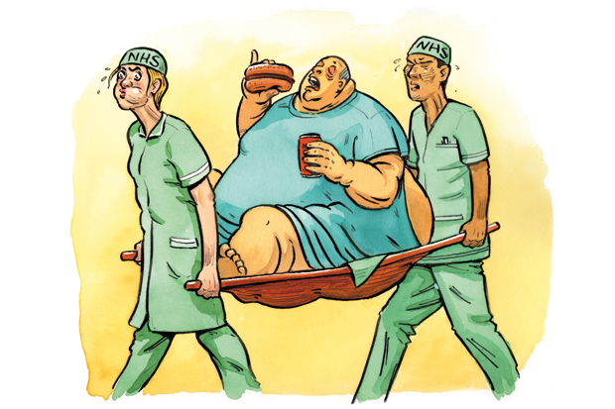

**Vaibhav Gupta - 17ucc064**

**Arya Shrivastava – 17ucs037**

**Abhi Mahajan – 17ucs004**

# Problem Statement

Recent studies have reported that globally, more than 1.9 billion adults are overweight and 650 million are obese. Approximately 2.8 million deaths are reported as a result of being overweight or obese. In India, abdominal obesity is one of the major risk factors for cardiovascular disease (CVDs). Various studies have shown that the prevalence of obesity among women was significantly higher as compared to men. Obesity is one of the main medical and financial burdens for the government. This problem of obesity can be preventable by spreading public awareness about obesity and its health consequences. Governmental agencies should promote the benefits of healthy lifestyle, food habits and physical activity. The aim of this project is to visualize the prevalence of obesity in different regions of India and highlight the problem areas.

# Visualization Used

Visualization used in this project is Bar Chart using D3.js library from JavaScript. Level of Obesity Vs Indian State are two arguments used for creating the Bar chart.

# Steps to run:

1. Go to the project directory using the Command Line/Terminal. E.g. cd ../../IViZ
2. Make sure you have Node installed on your system.
3. Run **npx http-server --cors** and the open localhost:8080 in the browser.

# Pros Of Using Bar Chart

1. Bar charts are pretty easy to interpret, and there's a very clear relationship between size and value that allows easy comparison.
2. They're simple to make and most people have experience creating and understanding them from school.
3. They can help in presenting very large or very small values more emphatically

# Cons Of Using Bar Chart

1. Bar charts that represent wide ranges of numbers will struggle to efficiently communicate their message.
2. Bar graphs tend to be locked into a particular data set, making it hard to show multiple values or changes over time unless the chart is modified, such as by making the bars layered and three-dimensional.

# Weaknesses of our Visualization

1. Only includes states showing Obesity levels >7% among resident men as more states would present information and jeopardize the discriminability.
2. Does not engage and answer any hypothesis concerning the cause of the prevailing obesity levels.

# RESULTS

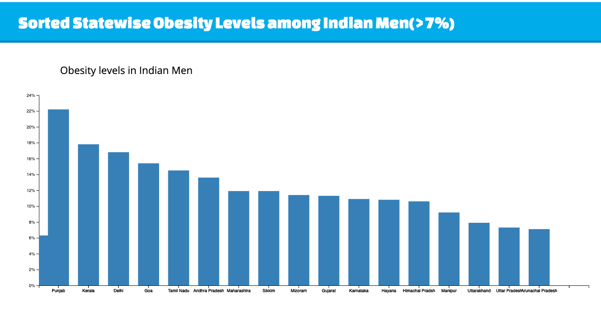

# CONCLUSION

We can clearly see from the above chart that Obesity is a prevalent disease in Indian Men especially those residing in Punjab, Kerala and the above studied states. We can clearly see the distribution of levels of obesity in different states of India where these rates are significant and above 7%.

# REFERENCES

1. https://data.gov.in/